30.File Upload
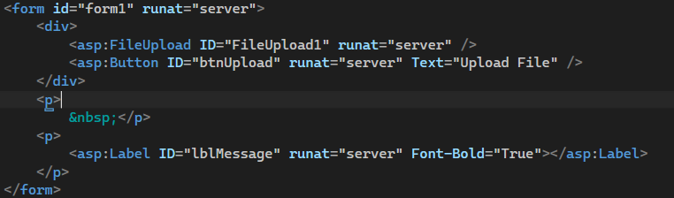
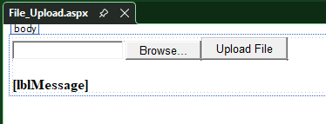
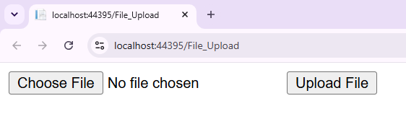
Create an upload folder
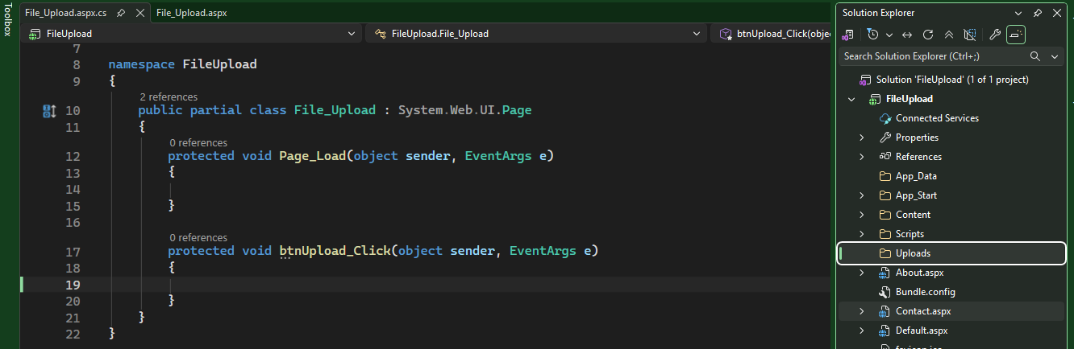
This method will upload the any types of files
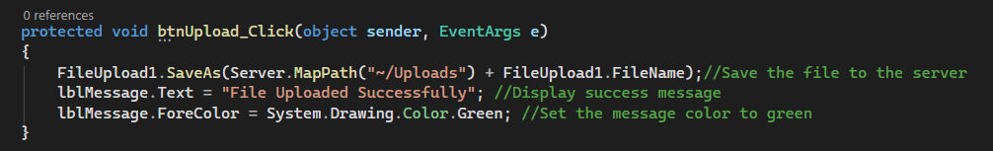
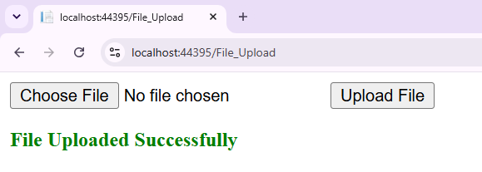
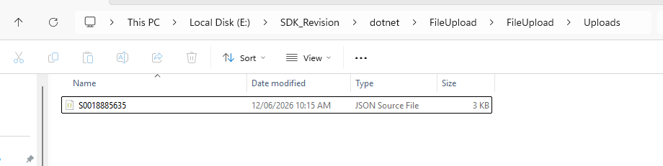
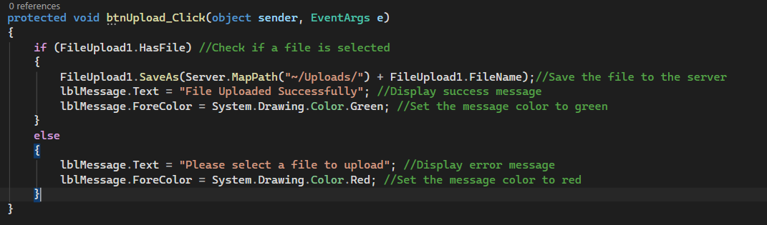
Want to allow only specific type file extension:
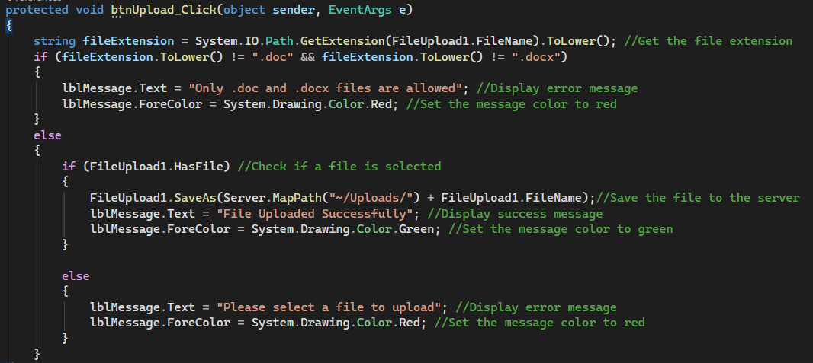
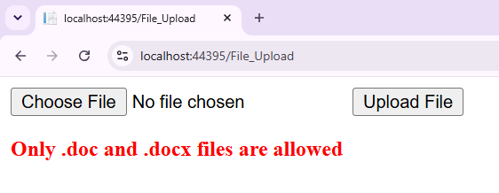
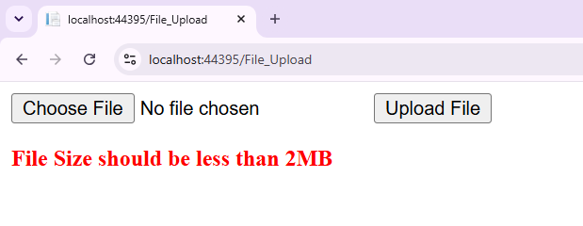
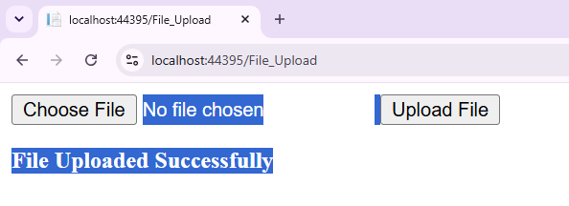
using Microsoft.Ajax.Utilities;
using System;
using System.Collections.Generic;
using System.Linq;
using System.Web;
using System.Web.UI;
using System.Web.UI.WebControls;

namespace FileUpload
{
public partial class File_Upload : System.Web.UI.Page
{
protected void Page_Load(object sender, EventArgs e)
{

}

protected void btnUpload_Click(object sender, EventArgs e)
{
string fileExtension = System.IO.Path.GetExtension(FileUpload1.FileName).ToLower(); //Get the file extension
if (fileExtension.ToLower() != ".doc" && fileExtension.ToLower() != ".docx")
{
lblMessage.Text = "Only .doc and .docx files are allowed"; //Display error message
lblMessage.ForeColor = System.Drawing.Color.Red; //Set the message color to red
}
else
{
if (FileUpload1.HasFile) //Check if a file is selected
{
int fileSize = FileUpload1.PostedFile.ContentLength; //Get the file size
if (fileSize > 2097152)
{
lblMessage.Text = "File Size should be less than 2MB";
lblMessage.ForeColor = System.Drawing.Color.Red;
}
else
{
FileUpload1.SaveAs(Server.MapPath("~/Uploads/") + FileUpload1.FileName);//Save the file to the server
lblMessage.Text = "File Uploaded Successfully"; //Display success message
lblMessage.ForeColor = System.Drawing.Color.Green;
}
}
else
{
lblMessage.Text = "Please select a file to upload"; //Display error message
lblMessage.ForeColor = System.Drawing.Color.Red;

}

}
}
}
}

